ONLY MONGO COMPLETE NOTES

MongoDB is an open source documented oriented No SQL
Stores in format called BSON type of JSON
Designed for flexibility scalability and performance in handling unstructured or semi structured.
Ex:
{
“name”: “kirtan”
}
Created by company called 10gen later called MongoDB by Eliot Horowitz and Merriman in 2007.
First mongo released in 2009
Name came from word HUMONGOUS == humongous

SQL VS MONGO (NO SQL)
Relational database Non-relational Database
Stored in table form flexible in data storage varied structure
Suitable for app with well Ideal for app with dynamics evolving
defined structure & models
fixed Schema
E-com Platform HR management Social Media Platforms, Gaming, CMS
MySQL PostgreSQL Oracle MongoDB, Redis

In SQL everything is pre-defined like primary key foreign key everything well-structured and planned
Student Table, Subject Table Grade Table
In mongo inside one collection you can add all the data
{
Id
Name
Age
Grade
Subject: [{}] //embedded document
}
Terminologies
Single database can have multiple collections inside it multiple documents can be present
#Schemaless but we can create Schema in mongoose

Key Features
- Flexible schema design
- Scalability and performance
- document oriented storage
- dynamic queries
- aggregation framework
- open source and community

Wired Tiger in name of storage engine used read and write data files in database in mongo DB
SQL vs NoSQL
SQL | NoSQL
Tables | Collections
Rows | Documents
Fixed Schema | Flexible Schema

BSON vs JSON
JSON | BSON
Human-readable | Binary format
Slower parsing | Faster parsing
Fewer data types | Supports more (Date, ObjectId, etc.)
More storage | Less storage required
Gets more complex as data gets bigger and complex | Well suited for handling large and complex datasets
Varies as data gets bigger | Mainatain perfomace efficiency despite large datasets

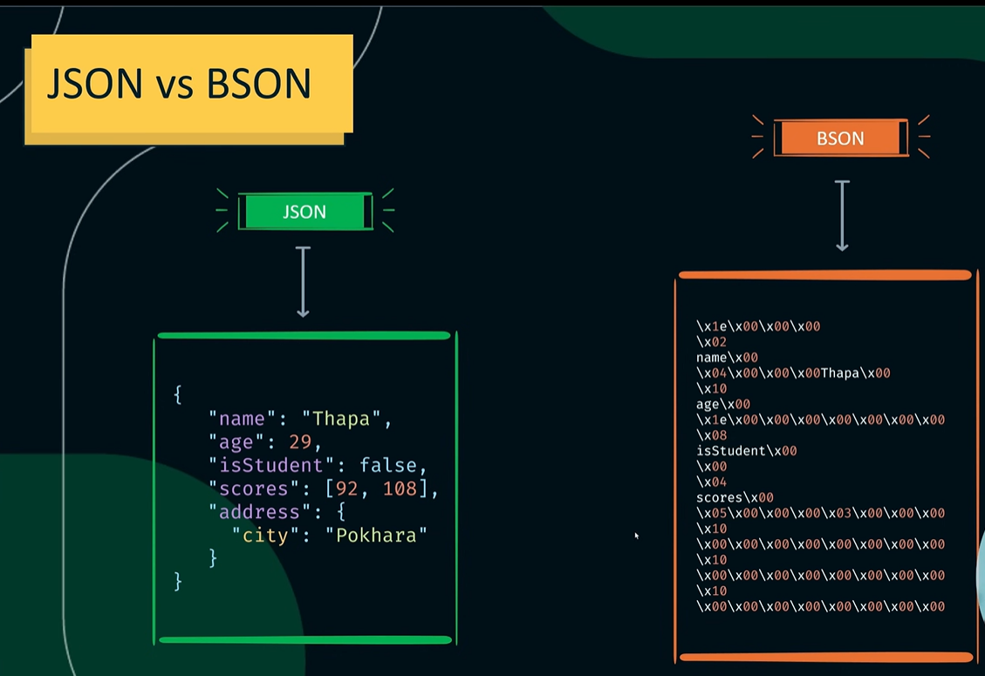

HOW MONGO WORKS
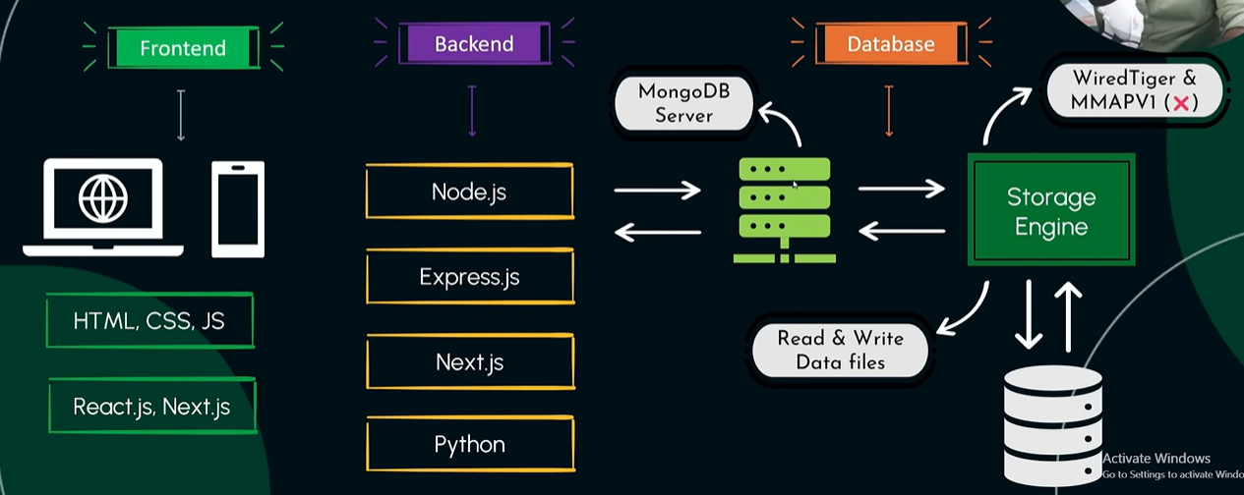
Can also use mongo shell to interact with database without need of backend connection
Managing Databases and Collections

show dbs; / show databases--- show all database
use <database-Name> ---changes or move to that database
db.dropDatabase() --- drop the existing database you are working on
show collections; --- show all collections
db.createCollection(‘<collection-name>’) --- create new collection
db.<collection-name>.drop() ---- drop collection

considering Club as Database name and collection names like players, coaches, positions
CRUD
Insert Operation / CREATE OPERTAIONS
db.players.insertOne({“name”: “cristiano”, “age”: “40”})
db.players.insertMany([{“name”: “cristiano”, “age”: “40”}, {“name”: “messi”, “age”: “37”}])
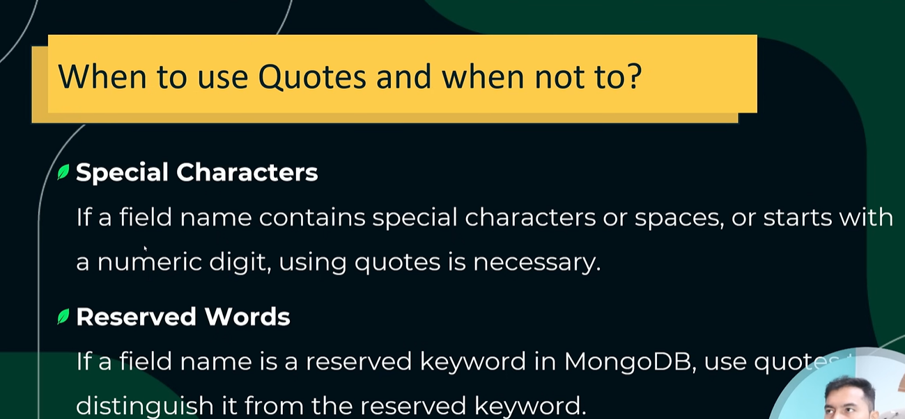

Ordered Inserts vs Unordered Inserts
Ordered: default behaviour is Ordered; mongo stops at first error.
in this everything gets inserted before error occurring and rest stops
Unordered: when executing bulk write operations with unordered flg, mongo continue process after encountering error.
In this only error get not inserted rest are added in database
db.players.insertMany([doc1,doc2….], {ordered: false});
// NAME ARE CASE SENSITIVE IN MONGODB player !== PLAYERS

READ OPERATIONS
-reading documents in MongoDB
-comparison Operators
- logical Operators
- cursors in MongoDB
- elements Operators

db.players.find() --- gives all data in collections
db.players.findOne({key:value}) --- find one particular element that matches condition
db.player.findMany({key:value})

IMPORTING JSON IN MONGODB
mongoimport jsonfile.json -d database_name -c collection_name
ex:
mongoimport product.json -d shop -c products - -jsonArray (if file is array of object)
mongoexport for exporting
mongoexport -d shop -c sales -o destination_palce/filename.json

COMPARISON OPERATOR
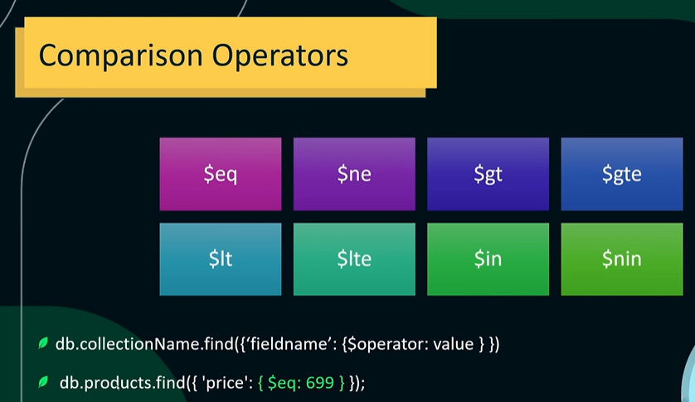
eq equal to
ne - not equal to
gt - greater than
gte - greater than equal to
lt - less than
lte - less than equal to
in - in operator
nin - not in operator
it – more

CURSORS IN MONGODB
Cursors in mongo DB are used for efficiently retrieve large result set from queries, providing control over the data retrieval process.
MongoDB retrieve query results in batching using cursors
cursors are pointers to the server set on the server
cursors are used to iterate through query results
AUTOMATIC BATCHING: in batches data comes
default batch size 101
this improves memory efficiency
.count()
.limit()
.skip()
.sort({price : 1/-1}) 1: asc ,-1: des
LOGICAL OPERATOR
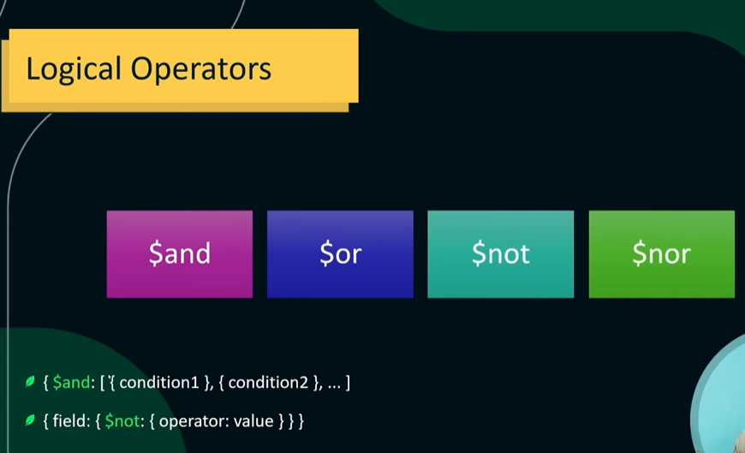
$and $or $not $nor
ex:
db.products.find({$and:[{price:{$gt:200}},{name :'Diamond Ring'}]})
if we romve $and write multiple condition find({},{}) it consider it as implicit function where it matches every condition than only will display output
db.products.find({price:{$gt:200}},{name :'Diamond Ring'}}) //same as above
db.products.find({$or:[{price:{$gt:200}},{name :'Diamond Ring'}]})

COMPLEX EXPRESSIONS

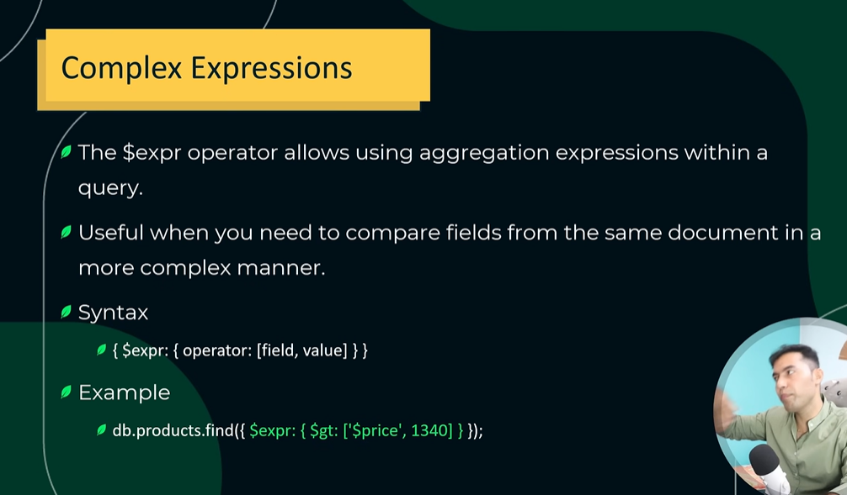
exp is mainly used for aggregation with a query

Q)expression to find sales who has quantity*price is greater than target price
Ans)
db.sales.find({
$expr:{
$gt:[{
$multiply:['$quantity','$price']
},
'$targetPrice'
]
}
})

ELEMENTS OPERATOR
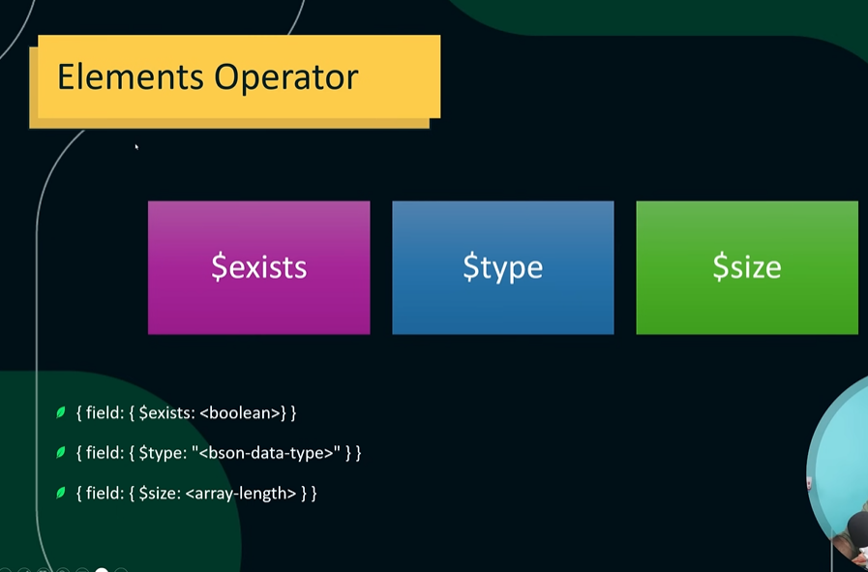

Q) find if price field exist in products collection
Ans) db.products.find({
price:{$exists :true}
})
Q) find price field if present check value greater than 1200
db.products.find({
price:{$exists:false},
price:{$gt:1250}
})

In type fieled we can directly add particular number which will determine the type of data.
ex: db.products({price:{$type :16}}).count() //16 denotes number data type
ex: db.products({price:{$type : ‘number’}}).count() – same as above
db.comments.find({‘comments’ :{$size:3}}) –in comments collection gives comments object where only two comments are there

BSON Type Number | Alias | Description
1 | "double" | 64-bit floating point number
2 | "string" | UTF-8 string
3 | "object" | Embedded document
4 | "array" | Array
5 | "bindata" | Binary data
6 | "undefined" | Undefined (deprecated)
7 | "objectId" | Object ID
8 | "bool" | Boolean (true/false)
9 | "date" | UTC Date and Time
10 | "null" | Null value
11 | "regex" | Regular expression
12 | "dbPointer" | DBPointer (deprecated)
13 | "javascript" | JavaScript code
14 | "symbol" | Symbol (deprecated)
15 | "javascriptWithScope" | JavaScript code with scope (deprecated)
16 | "int" | 32-bit integer
17 | "timestamp" | MongoDB internal timestamp
18 | "long" | 64-bit integer
19 | "decimal" | 128-bit decimal number
-1 | "minKey" | Smallest possible BSON value
127 | "maxKey" | Largest possible BSON valu

PROJECTIONS IN MONGODB
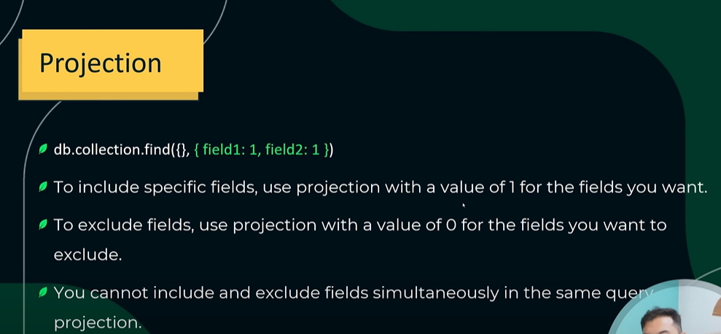

db.comments.find({‘comments’ : {$size:2}},{comments:1,_id :0 )})
you cant do like 1 0 1 0 to data like you want it to be visible and other to be hidden not possible here id is exceptions

MANAGING EMBEDDED DOCUMENTS

Q)to find complete data where commented user name is lily
db.comments.find({‘comments.user’: ‘Lily’})
Q)find data where views in meta data in greater than 1200
db.comments.find({'metadata.views':{$gt:1200}})
Q) find data where comment user should be henry and likes more than 50
db.comments.find({'comments.user':'Henry','metadata.likes':{$gt:50}})

$all and $elemMatch Functions
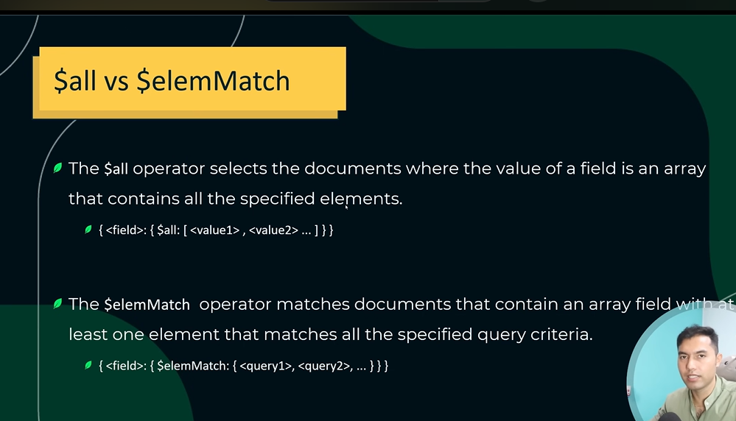

All example
Q) find data where comments user are alice and vinod
db.comments.find({'comments.user':{$all :['Alice','Vinod']}})
Element Match example
Q) find data where name is alice and text is Awesome article
db.comments.find({
'comments':{
$elemMatch:{
user:'Alice',text:'Awesome article!'
}
}
})
UPDATE OPERATION
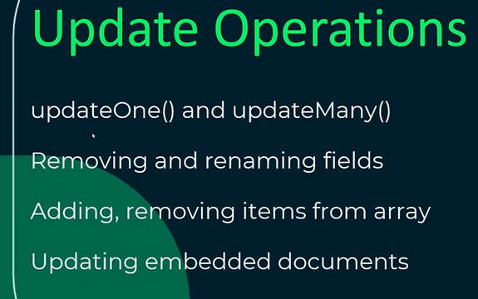
1) updateOne() and UpdateMany()
updateOne
db.comments.updateOne(
{author:'Vinod Thapa'},
{$set:{
author : 'Kirtan Nahar'
}}
)
updateMany
db.products.updateMany(
{name:'Designer Handbag'},
{$set:{
isFeatured:true
}}
)
Q)update filed isFeatured = true if price = 120
db.products.updateMany(
{price:120},
{$set:{
isFeatured:true
}}
)
2)Removing and Renaming filed
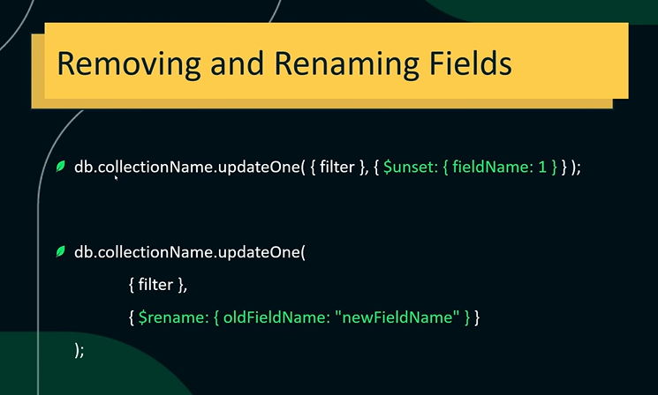
to removing the filed
db.products.updateMany(
{name:'Designer Handbag'},
{$unset:{
'isFeatures':1
}
}
)
to rename the field
db.products.updateMany(
{},
{$rename:{isFeatured:'isFeatures'}}
)

3)Updating arrays and Embedded Documents
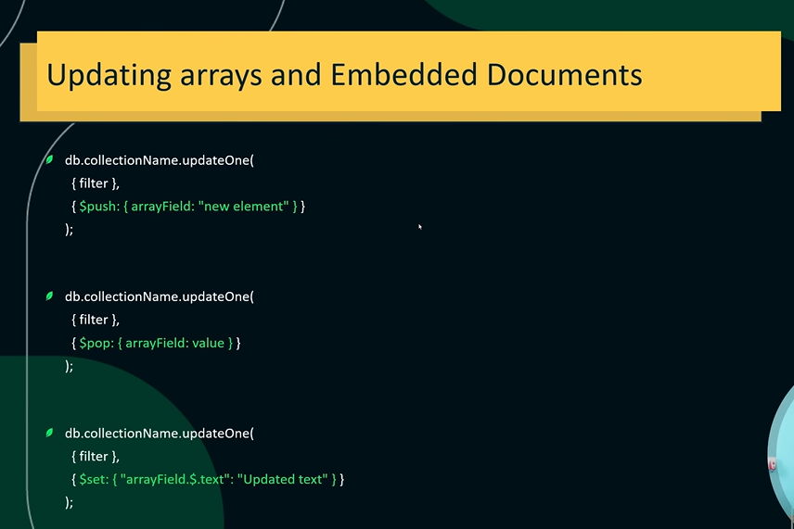
push in array of comments ex:
db.comments.updateOne(
{_id:5},
{
$push:{
comments:{
user:'kirtan',
}
}
}
)
pop in array of comments last inserted element
db.comments.updateOne(
{_id:5},
{
$pop:{
'comments':1
}
}
)
update in array using set operator to a particular field
db.comments.updateOne(
{_id:7,'comments.user':'Alice'},
{$set:{
'comments.$.text':'This is an example of updating text in embedded document'
}}
) // in set there is $ that is a positional operator that helps to define which field we need to update above case it was text

DELETE OPERATIONS
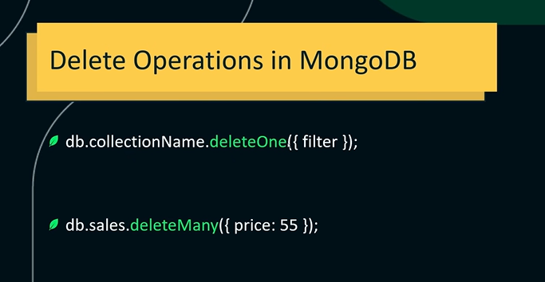
Q) delete sales data all price where value is 55
db.products.deleteMany({price:55})
Q) delete data in sales where id is 1
db.comments.deleteOne({_id:1})
INDEXES IN MONGODB
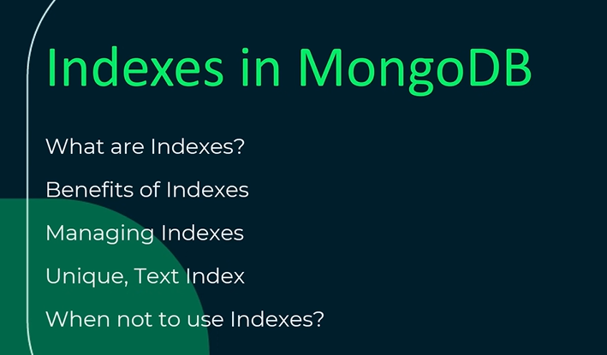
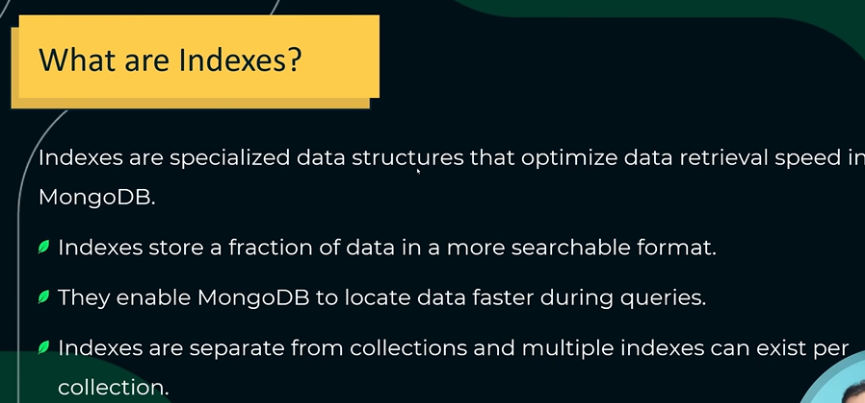
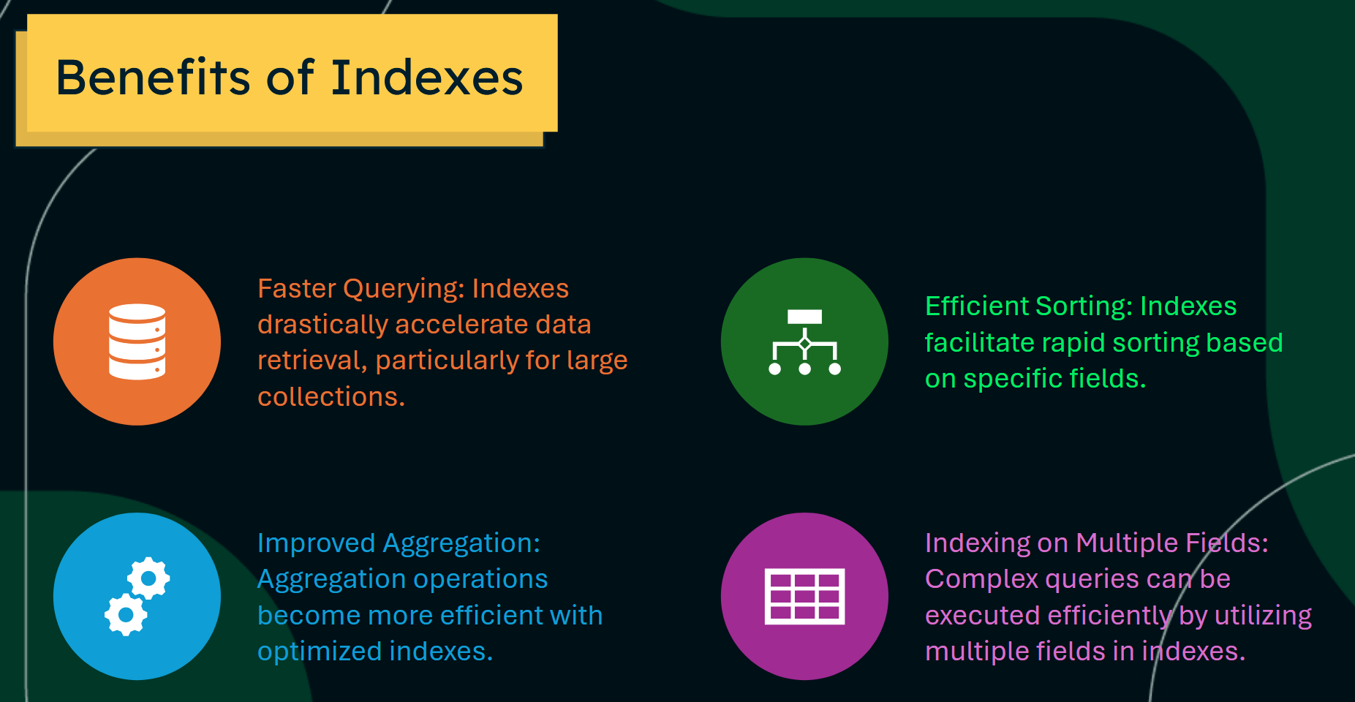
db.products.find({price:{$gt:100}})
db.products.find({price:{$gt:100}}).explain() – gives details of execution like search document
db.products.find({price:{$gt:100}}).explain('executionStats') ---gives more details of execution like time etc

index main use is to minimize the execution time
ex: like when you know that your data can be found in first 100 so why search 10000 of data this is where index is used
db.products.getIndexes() – used to check is there any indexes already present
db.products.createIndex({name:1}) – creating index in asec order for name like A B C
//if we search any field by name it will take very less time to execute previously it was following column scan(COLSCAN) and now name field will take index scan i.e. IXSCAN

db.products.dropIndex({name:1}) --- will drop the index
if want to create our field unique so no duplication of email can be there than you can create index with unique value = true
db.users.createIndec({email:1},{unique:true} – no duplicate mail can be present now //can be done in mongoose also while creating Schema
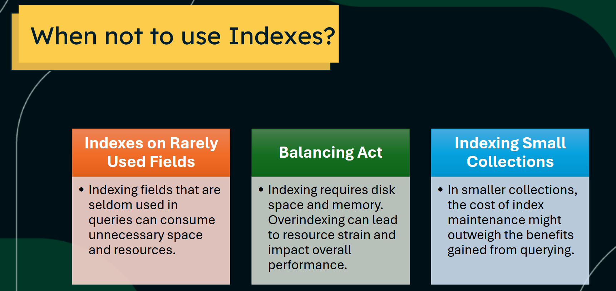

AGGREGATIONS IN MONGODB
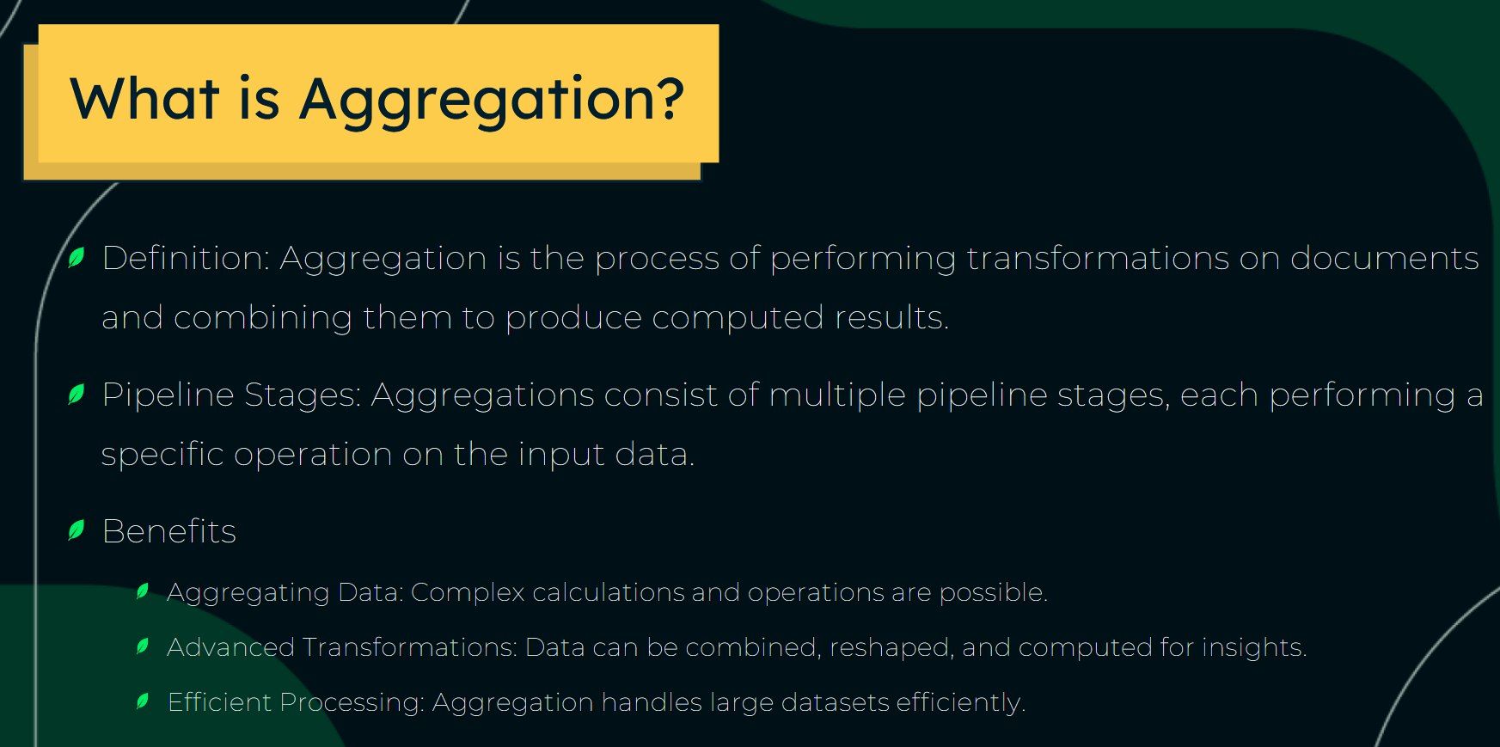
$match
is similar to the query used as the arguments in find(). it filters documents based on specified conditions
db.products.aggregate([
{$match:{
price: {$gt:1200}
}}
])

$group
it groups document by specified fields and performs aggregate operations on ground data
its like reduce in javascript where we want single output
db.products.aggregate([
{$group:{
_id:{comp:"$company"},
totalProducts:{$sum:1}
}}
])
//here we have grouped all company togther as a single one unit and create new field which tell how many products the hold
db.products.aggregate([{
$group :{_id:{comp: '$company'},totalSum :{$sum:'$price'}}
}])
// grouped based on same company id and added all price as sum togther
Q) sum all the price if price is more than 900 grouped by company
db.products.aggregate([
{$match:{price:{$gt:900}}},
{$group:{
_id:'$company',
totalSum : {$sum:'$price'}
}}
])
$sort
db.collection.aggregate([
{$sort:{‘$salaries’: 1/-1}
])

$project
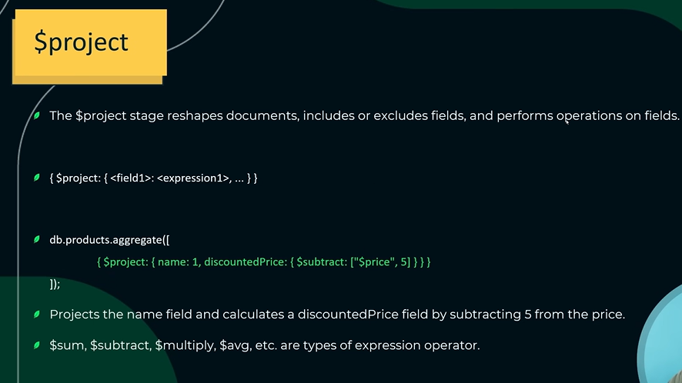
it is same as projection in of mongodb where we exclude and include fields.
ex: of projecting only name and discounted price for those products whose proce is greater than 1200
db.products.aggregate([
{$match:{price:{$gt:1200}}},
{$project:{
name:1,price:1,
discountedPrice : {$multiply:['$price',0.8]}
}}
])

$push
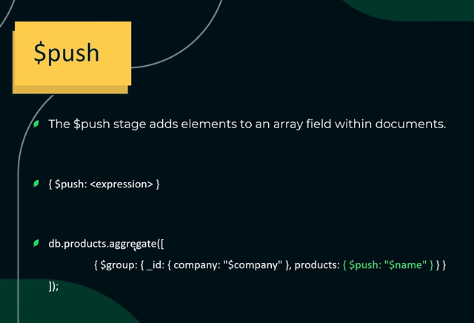
$unwind
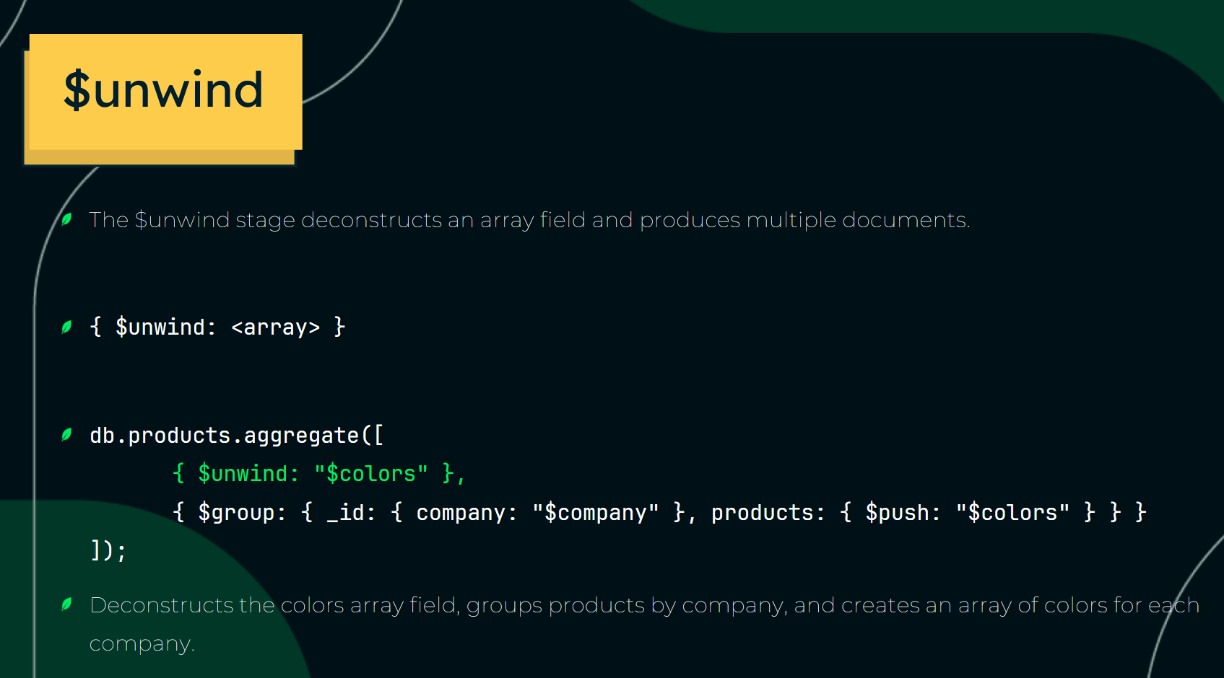
unwind mainly flats the array like if there are array inside array so it makes it one single array

Q) find doc gt 1200 and group them based on price and create array of colors for each group
db.products.aggregate([
{$match:{'price':{$gt:1200}}},
{$unwind:'$colors'},
{$group:{
_id:'$price',
allColors:{$push:'$colors'}
}}
])
$addToSet (for unique push)
above we were getting duplicate data in an array because of push but using addToSet we can only push unique data in array.
just replace $push to $addToSet
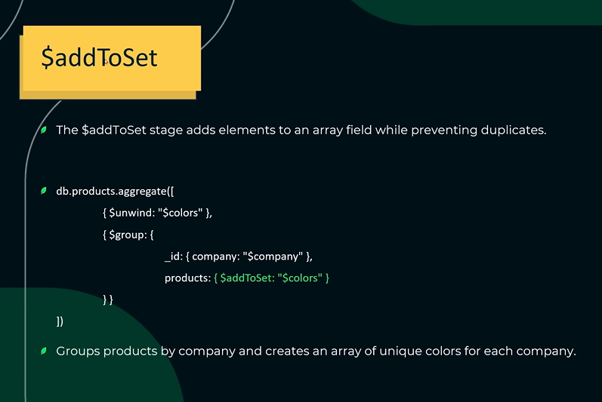
db.products.aggregate([
{$match:{'price':{$gt:1200}}},
{$unwind:'$colors'},
{$group:{
_id:'$price',
allColors:{$addToSet:'$colors'}
}}
])
$size
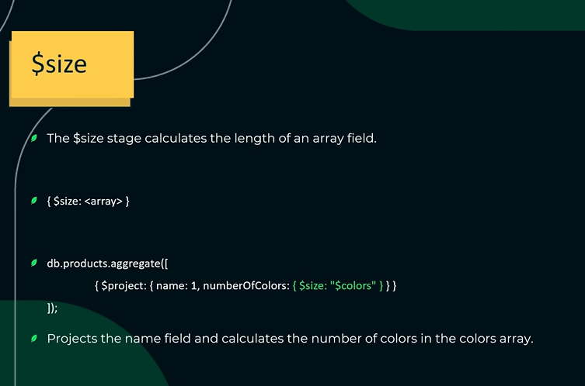
inside $group we cant use $size operator
//find also length in above addToSet cmd
db.products.aggregate([
{$match: {'price': {$gt: 1200}}},
{$unwind: '$colors'},
{$group: {
_id: '$price',
allColors: {$addToSet: '$colors'}
}},
{$project: {
_id: 1,
allColors: 1,
countLength: {$size: '$allColors'}
}}
])
$limit and $skip
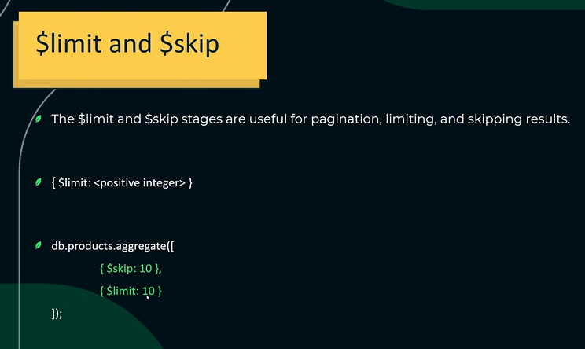
$filter
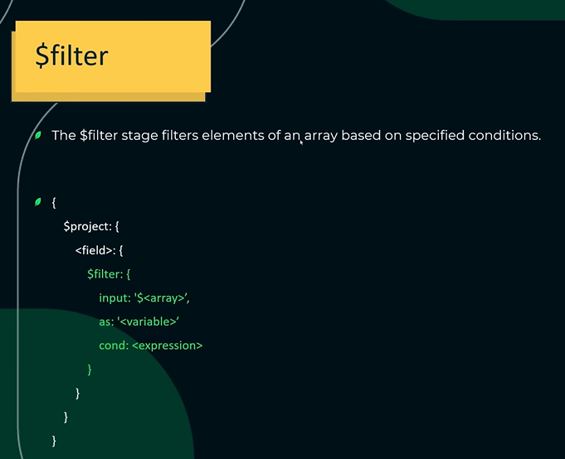
db.col.aggregate([
{$project:{
name:1,
MyValues:{
$filter:{
input:'$values',
as:'val',//alyias name
cond:{$gt:['$$val',30]} //when we want to represent allias variable
//that is ref other field that is present in
//real datafild we use $$
}
}
}}
])

$concatArrays
db.reports.updateOne(
{ "_id": 2 },
[
{
$set: {
"revisions": {
$concatArrays: [
"$revisions", // [2022, 2023]
["$currentYear"] // [2024] - Must be passed as an array
]
}}}
])
// Result: {"_id": 2, "title": "Report A", "revisions": [2022, 2023, 2024], "currentYear": 2024}

$cond
$cond evaluates and returns the value of the <true-case> expression. Otherwise, $cond evaluates and returns the value of the <false-case> expression.
db.products.aggregate([
{$match: {'price': {$gt: 1200}}},
{$unwind: '$colors'},
{$group: {
_id: '$price',
allColors: {$addToSet: '$colors'}
}},
{$project: {
_id: 1,
allColors: 1,
countLength: {
$cond: {
if: {$eq: [{$type: '$allColors'}, 'array']},
then: {$size: '$allColors'},
else: 0
}
}
}}
])

